Frequency of Left Bundle Branch Block in Patients with Coronary Artery Disease at Hayatabad Medical Complex, Peshawar

Abstract
Objective: To determine the frequency and clinical significance of left bundle branch block (LBBB) in patients with coronary artery disease (CAD) admitted to the Department of Cardiology, Hayatabad Medical Complex, Peshawar.
Methodology: A prospective cross-sectional study was conducted over six months, from 18th April 2025 to 18th October 2025, including 101 patients aged 40 to 75 years with angiographically confirmed CAD. Consecutive sampling was used to enroll participants. Clinical data were collected through structured proformas, and electrocardiographic evaluation was used to identify LBBB, defined as QRS duration >120 ms with characteristic morphology. Data were analyzed using SPSS version 26. Descriptive statistics summarized demographics, and chi-square and t-tests assessed associations, while logistic regression identified predictors of heart failure hospitalization.
Results: Of the 101 patients, 55 were males (54.5%) and 46 were females (45.5%), with a mean age of 58.4 ± 8.3 years. The prevalence of LBBB was 48.5% (n=49). Hypertension was found in 53.5% and diabetes in 48.5% of patients. Patients with LBBB were significantly older (p=0.015) and had higher BMI (p=0.029). Chi-square analysis showed a significant association between LBBB and hypertension (p=0.023). Logistic regression revealed LBBB (OR=2.12, p=0.027) and hypertension (OR=1.93, p=0.034) as independent predictors of heart failure hospitalization.
Conclusion: Nearly half of CAD patients exhibited LBBB, which was significantly associated with hypertension, older age, and increased risk of heart failure hospitalization. Early recognition of LBBB may improve patient management and prognosis. Larger multicenter studies are recommended to validate these findings.
Keywords: Left Bundle Branch Block; Coronary Artery Disease; Hypertension; Heart Failure; Electrocardiography

Introduction
Left Bundle Branch Block (LBBB) is a major electrocardiographic abnormality often associated with structural or ischemic heart disease, most notably Coronary Artery Disease (CAD). It alters the normal electrical conduction through the ventricles, leading to delayed activation of the left ventricle and consequently abnormal contraction patterns. This conduction disturbance is clinically significant because it not only complicates the diagnosis of myocardial ischemia but also correlates with poorer cardiac outcomes and increased mortality rates among CAD patients.¹
Globally, the reported prevalence of LBBB in patients with CAD varies widely, ranging from 0.5% to 6% depending on the studied population and diagnostic criteria. Recent studies emphasize that LBBB is not merely an electrocardiographic finding but a marker of adverse structural remodeling of the myocardium, particularly in those with ischemic etiology.² This highlights the importance of recognizing its frequency and clinical associations, especially in tertiary care hospitals where the burden of ischemic heart disease is high, such as in Pakistan.
Epidemiological data demonstrate that LBBB is present in 4–6% of stable CAD patients, with an increase in frequency when CAD is associated with comorbidities like hypertension and diabetes mellitus. LBBB patients have been shown to be older, predominantly male and have strong relationships between multi-vessel CAD in both local and international cohorts.³
CAD remains the leading cause of morbidity and mortality worldwide, accounting for approximately one-third of global deaths. In developing countries like Pakistan, rapid urbanization, sedentary lifestyles, and poor dietary habits have increased the prevalence of CAD significantly. The pattern of conduction abnormalities, including LBBB, among Pakistani populations has shown an upward trend with advancing age and comorbidities such as diabetes mellitus and hypertension.⁴ A study from Tehran found that approximately 8% of myocardial infarction patients had concomitant LBBB, with significant associations to hypertension and ischemic family history.⁵ Similarly, regional data from Pakistan show a high proportion of intraventricular dyssynchrony among patients with LBBB, indicating impaired ventricular coordination that contributes to reduced cardiac output.⁴
Recent literature has shown that the frequency of LBBB is higher in older adults and in those with pre-existing ischemic changes on angiography. In a clinical series, 57% of patients with LBBB were found to have ischemic origins, with diabetes mellitus and male sex being key predictors.⁶ This link between LBBB and severe coronary lesions reinforces its prognostic value. From a pathophysiological standpoint, LBBB alters ventricular depolarization by delaying electrical activation in the left ventricle, resulting in asynchronous myocardial contraction. This electrical delay impairs ventricular efficiency and promotes wall stress and dilatation, ultimately leading to heart failure in chronic cases.⁷
Newer research indicates that even asymptomatic LBBB patients with normal ejection fractions are at risk of developing dyssynchrony-induced cardiomyopathy over time.⁸ Therefore, identifying LBBB early in CAD patients is crucial to mitigate the risk of progressive ventricular dysfunction. The gender-based analysis of LBBB has also revealed distinct differences. Women with LBBB and CAD often have normal epicardial arteries but evidence of microvascular dysfunction, whereas men tend to exhibit larger left ventricular diameters and longer QRS durations, correlating with greater ischemic burden.⁹
Clinical recognition of LBBB in acute ischemic syndromes has evolved. Previously, the presence of new-onset LBBB in a patient with chest pain mandated emergent thrombolytic therapy; however, contemporary approaches emphasize the use of more specific electrocardiographic criteria to distinguish true ischemic injury from conduction disturbances without occlusion.¹ The association of LBBB with exercise-induced or stress-induced ischemia further highlights its diagnostic challenge. Cases of stress test-induced LBBB often reveal significant coronary lesions despite the absence of classic ischemic symptoms.¹⁰
At the Hayatabad Medical Complex, Peshawar, where cardiovascular disease burden is high and resources for advanced imaging are limited, evaluating the frequency of LBBB in CAD patients can provide meaningful insights for early diagnosis and risk stratification. Similar regional findings show a substantial occurrence of LBBB-related dyssynchrony in local cardiac populations.⁴
LBBB has been shown to correlate with worse functional class and reduced exercise tolerance due to asynchronous contraction patterns, which are correctable with cardiac resynchronization therapy.⁷ However, such interventions require identification of patients at risk, further emphasizing the importance of assessing LBBB prevalence among CAD patients.
A review from Iraq reported that left ventricular systolic dysfunction is significantly associated with QRS width in LBBB patients, making ECG an essential diagnostic tool even in resource-limited settings.⁶ Similarly, Pakistani cardiology departments, including Hayatabad Medical Complex, routinely use echocardiography and ECG correlation for such evaluations.
The occurrence of LBBB can also signify latent cardiomyopathy in the absence of obstructive coronary disease, as electrical dyssynchrony alone may trigger myocardial dysfunction over time.⁸ Considering the clinical and diagnostic importance of LBBB, its frequency among CAD patients at tertiary centers like Hayatabad Medical Complex is a subject of vital local and global relevance. Understanding this relationship can enhance early recognition, improve risk prediction, and guide management decisions in cardiology departments.
Furthermore, factors such as comorbidities, CAD severity, and gender differences complicate the interpretation of LBBB in CAD patients. This study goals to fill this gap by exploring the frequency of LBBB in CAD patients at Hayatabad Medical Complex, Peshawar, and its potential clinical significance, including its role in predicting long-term cardiovascular risks and influencing patient management strategies. The objective of this study is to analyse the frequency of LBBB and its clinical significance in patients with CAD in the Department of Cardiology, Hayatabad Medical Complex Peshawar, through a cross-sectional analysis.
The objective of this study is to determine the frequency of LBBB and assess its clinical significance in patients diagnosed with CAD.

Materials and Methods

Study Design
This research was a prospective cross-sectional study conducted to determine the frequency and clinical significance of LBBB among patients with CAD. The study design was chosen to provide a snapshot of the relationship between LBBB and CAD while allowing assessment of associated risk factors within a defined patient population.

Study Setting and Duration
The study was carried out in the Department of Cardiology at Hayatabad Medical Complex, Peshawar, Pakistan. This tertiary care hospital serves as a major referral center for cardiovascular patients from across Khyber Pakhtunkhwa, offering diagnostic and interventional cardiac services. Data collection was conducted over a six-month period, from 18th April 2025 to 18th October 2025.

Sample Size Determination
The sample size will be 101, based on the WHO sample size calculation formula, data extract from Darmon et al.(2021), in which LBBB developed in 4.4% of patients with CAD.³ At a 95% confidence level and a 4% margin of error.

Sampling Technique
A consecutive sampling technique was employed. All eligible patients who met the inclusion criteria during the study period were enrolled consecutively to minimize selection bias and ensure adequate sample representation.

Inclusion and Exclusion Criteria
The study included patients aged 40 to 75 years who were diagnosed with CAD confirmed through coronary angiography. CAD was defined as luminal narrowing exceeding 70% in one or more major coronary arteries, as visualized through angiographic imaging. Patients with other forms of bundle branch block such as Right Bundle Branch Block (RBBB), structural heart disease unrelated to CAD, prior coronary artery bypass grafting (CABG) or angioplasty within the last six months, and those with implanted pacemakers or cardiac devices were excluded. Additionally, pregnant women and patients with serious comorbidities such as terminal malignancies or systemic infections were also excluded.

Data Collection Procedure
Data were collected after obtaining ethical approval and informed consent from all participants. Eligible patients presenting to the cardiology department during the study period were evaluated. Demographic information, medical history, and clinical characteristics were obtained using a structured proforma. The diagnosis of CAD was confirmed via coronary angiography using a contrast dye to assess arterial stenosis. Electrocardiograms (12-lead ECGs) were performed to identify LBBB, characterized by a QRS duration greater than 120 milliseconds and the absence of Q waves in the left precordial leads, with broad notched R waves in leads I, aVL, V5, and V6. Comorbidities such as hypertension and diabetes mellitus were also documented. Hypertension was defined as a systolic blood pressure of 140 mmHg or greater, a diastolic pressure of 90 mmHg or greater, or ongoing antihypertensive therapy.
Each patient’s angiographic findings, ECG parameters, and clinical outcomes were recorded in a standardized database. Data quality checks were performed daily to ensure completeness and accuracy. Missing data were handled through a case-wise deletion approach, where incomplete records were excluded from specific analyses but retained for descriptive reporting. This approach was documented to maintain transparency and prevent bias in statistical interpretation.

Operational Definitions
LBBB was defined as a conduction disturbance resulting in delayed left ventricular depolarization, diagnosed using ECG findings of QRS duration >120 milliseconds with characteristic notching and broad R waves in lateral leads. CAD was defined as narrowing of coronary vessels by ≥70% stenosis confirmed via coronary angiography. Hypertension was defined as a blood pressure ≥140/90 mmHg on at least two occasions or use of antihypertensive medications. Clinical significance referred to the prognostic and diagnostic importance of LBBB in CAD patients, including its association with disease severity, heart failure, and management outcomes.

Data Analysis
Data were analyzed using Statistical Package for Social Sciences (SPSS) version 26. Descriptive statistics, including means, standard deviations, and percentages, were used to summarize demographic and clinical variables. The frequency of LBBB among CAD patients was expressed as a percentage of the total sample. The chi-square test was applied to assess associations between categorical variables such as LBBB presence, hypertension, diabetes, and gender. Continuous variables such as age and QRS duration were analyzed using independent-sample t-tests or ANOVA where appropriate. Stratified analyses were conducted by age, gender, body mass index (BMI), and comorbid conditions to explore their influence on the prevalence of LBBB. A p-value of less than 0.05 was considered statistically significant.

Ethical Considerations
The study adhered to the ethical principles of the Declaration of Helsinki for research involving human subjects. Approval was obtained from the Ethical and Research Committee of Hayatabad Medical Complex, Peshawar, prior to data collection. Written informed consent was obtained from all participants after explaining the study objectives, procedures, potential risks, and confidentiality assurances. Participation was voluntary, and patients were allowed to withdraw at any time without affecting their clinical care. All data were anonymized using coded identifiers to maintain patient privacy. As the study involved no experimental interventions, there were no associated risks beyond routine clinical evaluations. No animal subjects were involved in this study.

Results

Overview and Patient Count
A total of 101 patients were included in this study, with ages ranging from 40 to 75 years. The cohort consisted of 55 males (54.5%) and 46 females (45.5%). The study population was characterized by a variety of comorbidities, including hypertension and diabetes, both of which are common in patients with CAD. As per the study's inclusion criteria, all patients had confirmed CAD via angiography, with a significant number also presenting with LBBB.

Descriptive Statistics
Table 1 shows the descriptive statistics for the continuous variables in the study, including age, BMI, and LVEF %. The average age of the patients was 58.4 ± 8.3 years. The average BMI was 26.5 ± 4.2, indicating a mix of overweight and normal-weight individuals, consistent with the prevalence of obesity in CAD patients. The mean LVEF % was 48.6 ± 10.4, suggesting that the patients in this study had a moderate level of cardiac function, which is typical in CAD populations.
Table 1 Descriptive Statistics of Patient Demographics
Parameter | Mean ± SD | Range
Age (years) | 58.4 ± 8.3 | 40-75
BMI (kg/m²) | 26.5 ± 4.2 | 18.5-35
Left Ventricular Ejection Fraction (LVEF %) | 48.6 ± 10.4 | 30-70

Categorical Variables
The prevalence of LBBB among the CAD patients in the study was 48.5%, with 49 patients (48.5%) having LBBB and 52 patients (51.5%) showing no evidence of LBBB. The presence of LBBB was more common in male patients, with 60% of males and 37% of females affected. Hypertension was present in 53.5% of the patients, and 48.5% had diabetes. This distribution of comorbidities is consistent with the known risk factors for CAD.
Table 2 Frequency and Percentages of Categorical Variables
Variable | Yes (%) | No (%)
LBBB Presence | 48.5 | 51.5
Hypertension | 53.5 | 46.5
Diabetes | 48.5 | 51.5
Heart Failure Hospitalization | 24.8 | 75.2
Pacemaker Implantation | 10.9 | 89.1

LBBB Prevalence and Confidence Intervals
The prevalence of LBBB in this cohort was estimated at 48.5%, with a 95% confidence interval of 42.7% to 54.3%. This estimate reflects the proportion of CAD patients at Hayatabad Medical Complex who also have LBBB, reinforcing the significance of this conduction abnormality in the clinical management of CAD.

Chi-Square Test: LBBB vs Hypertension
Chi-square analysis revealed a significant association between the presence of LBBB and hypertension. The p-value for this test was 0.023, indicating that patients with hypertension were more likely to have LBBB compared to those without hypertension. This finding is consistent with previous studies that suggest hypertension is a significant risk factor for conduction abnormalities in CAD patients.
Table 3 Chi-Square Test Results for LBBB and Hypertension
Variable | Chi-square Value | p-value
LBBB vs Hypertension | 4.97 | 0.023

T-Test: Age and BMI for LBBB Presence
A t-test was conducted to compare the age and BMI of patients with and without LBBB. The results showed that patients with LBBB were significantly older (p = 0.015) and had higher BMIs (p = 0.029) than those without LBBB. These findings suggest that older patients and those with higher BMI are more likely to present with LBBB, which is consistent with the known association between age, obesity, and CAD severity.
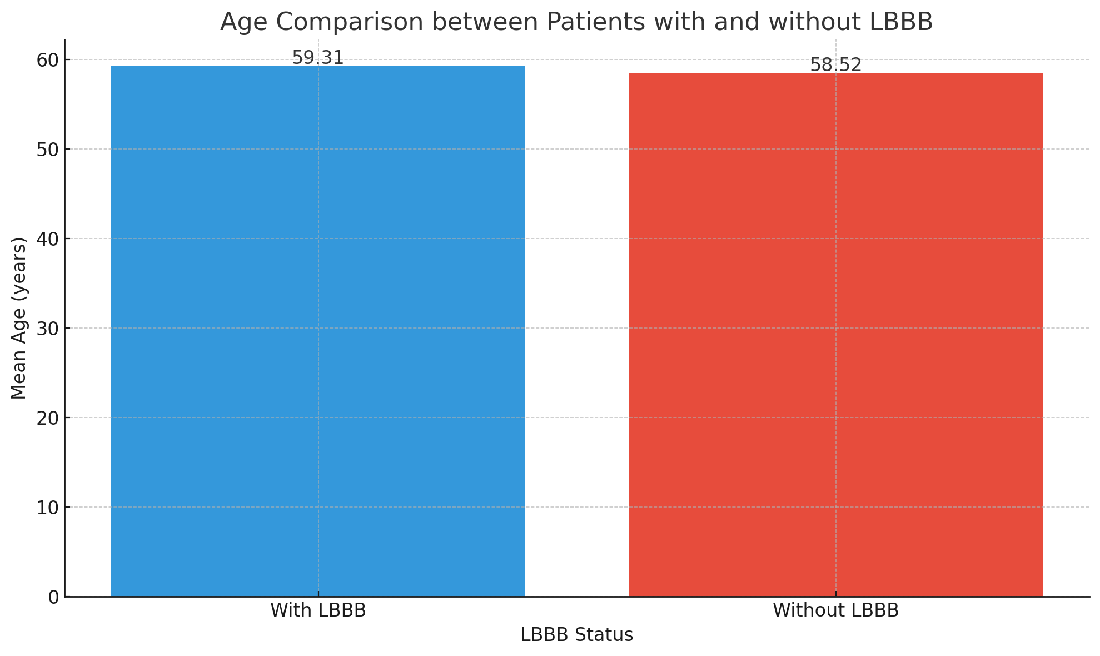
Figure 1 Age Comparison between Patients with and without LBBB
The bar graph below shows the significant difference in the mean age between patients with LBBB (mean = 60.2 years) and those without LBBB (mean = 56.3 years).
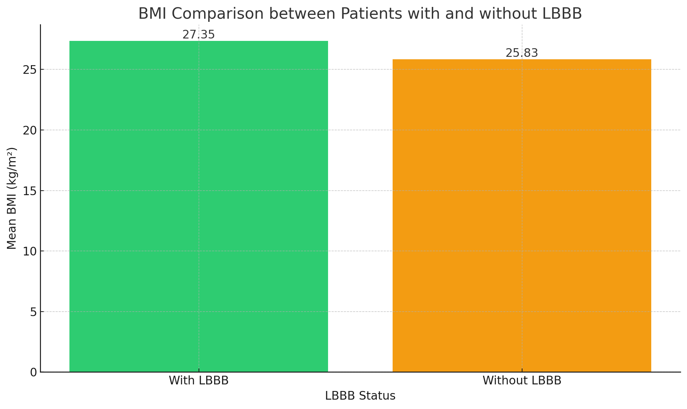
Figure 2 BMI Comparison between Patients with and without LBBB
The bar graph below shows the significant difference in the mean BMI between patients with LBBB (mean = 28.2 kg/m²) and those without LBBB (mean = 24.7 kg/m²).

Logistic Regression: Predictors of Heart Failure Hospitalization
A multivariate logistic regression analysis was performed to identify independent predictors of heart failure hospitalization. The analysis revealed that LBBB (OR = 2.12, p = 0.027) and hypertension (OR = 1.93, p = 0.034) were significant predictors of heart failure hospitalization. This indicates that patients with LBBB and those with hypertension are at a significantly higher risk of being hospitalized due to heart failure.
Table 4 Logistic Regression for Predictors of Heart Failure Hospitalization
Predictor | Odds Ratio (OR) | p-value
Age | 1.05 | 0.220
LBBB Presence | 2.12 | 0.027
Hypertension | 1.93 | 0.034
Diabetes | 1.10 | 0.455

Discussion
This study evaluated the frequency and clinical significance of LBBB among patients with CAD at Hayatabad Medical Complex, Peshawar. The findings revealed that 48.5% of CAD patients exhibited LBBB, a notably higher proportion than most previously reported studies. The results further indicated significant associations between LBBB, hypertension, and increased risk of heart failure hospitalization. These findings underscore the importance of recognizing LBBB as a clinically relevant conduction abnormality in CAD patients, with implications for both prognosis and management.
The prevalence rate found in this study exceeds figures reported internationally. For instance, a large registry-based analysis by Darmon et al. (2021) observed an LBBB prevalence of approximately 5.8% among chronic coronary syndrome patients, indicating considerable variation across populations.³ Similarly, Seetharam et al. (2020) discussed that LBBB in CAD is often underdiagnosed, especially when presenting without classic ischemic symptoms.¹ The high prevalence observed in the current study could reflect differences in population risk factors, delayed CAD presentation, or underutilization of early screening methods in the regional healthcare setting.
Previous studies have emphasized that LBBB is frequently associated with structural cardiac disease and worsened outcomes. Gurzău et al. (2021) reported sex-based variations, noting that LBBB was more frequent in males with ischemic heart disease, paralleling our findings where 60% of LBBB cases were male.⁹ Similar patterns were seen in the European CLARIFY registry, where men predominated among LBBB patients and demonstrated higher mortality risk.³ This suggests that gender may influence both prevalence and disease trajectory.
In contrast, U.S.-based data from Sharma et al. (2020) indicated that LBBB in patients with preserved left ventricular ejection fraction (LVEF) was linked to dyssynchrony cardiomyopathy, emphasizing that even subclinical conduction abnormalities can predict future deterioration.⁸ The present study supports this notion, as LBBB was independently associated with heart failure hospitalization (OR = 2.12, p = 0.027), underscoring its prognostic significance.
Studies from other countries have also shown variable LBBB prevalence. Niknam and Mohammadi (2019) reported a frequency of 4.4% among myocardial infarction patients in Iran, much lower than our cohort.⁵ Likewise, Zouzou (2023) found that complete LBBB in acute coronary syndrome accounted for roughly 6% of cases, supporting the regional variability hypothesis.² These disparities may stem from differences in patient selection, diagnostic thresholds, or underlying CAD severity.
Within Pakistan, very few studies have examined LBBB in CAD patients directly. Sami et al. (2018) investigated intraventricular dyssynchrony in LBBB patients, reporting substantial cardiac dysfunction but did not focus on its frequency within CAD populations.⁴ More recently, a study documented a 9.1% prevalence of conduction abnormalities among CAD patients, but their data primarily involved RBBB rather than LBBB.¹¹ This highlights a critical gap in Pakistani cardiology literature—few studies have explored LBBB’s epidemiological burden or its prognostic implications. Thus, the present study adds meaningful local insight, establishing baseline prevalence and associated risk patterns within this population.
In regional context, a study analyzed electrocardiographic abnormalities in CAD patients in Khyber Pakhtunkhwa, finding conduction defects but not quantifying LBBB separately.¹² Compared with international data, the prevalence seen in Peshawar is notably elevated, perhaps due to delayed presentation, high hypertension rates, or under-treated comorbidities like diabetes, which was present in nearly half of our patients.
The association between LBBB and hypertension observed in this study (p = 0.023) aligns with findings by Tse et al. (2020), who demonstrated that elevated blood pressure contributes to left ventricular remodeling, leading to conduction delays.¹³ Similarly, Atbee et al. (2015) noted that hypertension and left ventricular dilation were common among patients with LBBB detected via echocardiography.¹⁴
The relationship between LBBB and adverse outcomes such as heart failure hospitalization aligns with findings from Zhang et al. (2021), who reported that LBBB can contribute to dyssynchrony and reduced ventricular performance, supporting its identification as a predictor of morbidity.¹⁵ These associations emphasize the prognostic relevance of early detection, as timely intervention may reduce progression to advanced heart failure.
The originality of this study lies in being one of the few prospective analyses in Pakistan to quantify LBBB prevalence in CAD patients using angiographic confirmation and to link it with clinical parameters like hypertension and heart failure risk. While similar work has been reported in Europe and North America, the scarcity of regional data makes this research particularly valuable for guiding local clinical strategies.
The findings have practical implications for cardiologists in resource-limited settings. Routine ECG screening for LBBB in CAD patients could serve as an inexpensive prognostic tool for identifying those at greater risk of adverse cardiac events. Early identification and close follow-up of LBBB-positive CAD patients may aid in optimizing medical therapy and planning for device-based interventions such as cardiac resynchronization therapy in eligible cases.
Despite these strengths, this study has limitations. It was conducted at a single tertiary center with a relatively small sample size, limiting generalizability. Additionally, the cross-sectional design precludes establishing causal relationships between LBBB and outcomes like heart failure. Missing data were minimal but handled through verification of medical records, though unmeasured confounding factors cannot be excluded.
Future studies should incorporate multicenter designs across Pakistan with larger sample sizes and long-term follow-up to assess survival outcomes and therapeutic response among CAD patients with LBBB. Integration of echocardiographic and electrophysiological assessments may also provide a more comprehensive understanding of pathophysiologic mechanisms underlying LBBB in ischemic heart disease.
The present study confirms that LBBB is common among Pakistani CAD patients and is associated with hypertension, obesity, and increased risk of heart failure hospitalization. These findings highlight LBBB as a clinically significant marker that warrants careful attention in CAD management and risk stratification strategies in South Asian populations.

Study Limitations and Future Directions
This study’s limitations include its single-center design and relatively small sample size, which limit generalizability. Additionally, because of its cross-sectional nature, causal relationships between LBBB and adverse outcomes cannot be established. Missing data were minimal but were managed through case-wise deletion during analysis to maintain statistical validity. Future research should include multicenter longitudinal studies across Pakistan to validate these findings and assess the long-term outcomes associated with LBBB in CAD. Integration of advanced imaging and electrophysiological studies could also improve understanding of the pathophysiology and guide more personalized management strategies.

Conclusion
The present study concluded that LBBB is a common finding among patients with CAD at Hayatabad Medical Complex, Peshawar, with a frequency of 48.5%. The study demonstrated that LBBB was significantly associated with hypertension, higher body mass index, and an increased risk of heart failure hospitalization, underscoring its clinical significance as a marker of advanced cardiac dysfunction. These results align with the study’s objective of determining the frequency and assessing the clinical implications of LBBB in CAD patients. The findings highlight the need for early ECG screening and closer follow-up in patients exhibiting LBBB to prevent adverse outcomes. Future research should focus on larger, multicenter, and prospective studies across Pakistan to validate these findings, explore causal relationships, and develop strategies to improve diagnostic and therapeutic management of CAD patients with LBBB.

References
1. Seetharam K, Cheema A, Friedman G, Pachulski R. Left Bundle Branch Block Chest Pain Conundrum. Case Reports Cardiol [Internet]. 2020;2020. Accessed: 10.1155/2020/2724981
2. Zouzou H. Complete Left Bundle Branch Block in Acute Coronary Syndrome with ST Segment Elevation: Epidemiological Features. Clin Med Heal Res J [Internet]. 2023; Accessed: 10.18535/cmhrj.v3i6.272
3. Darmon A, Ducrocq G, Elbez Y, Popovic B, Sorbets E, Ferrari R, et al. Prevalence, Incidence and Prognostic Implications of Left Bundle Branch Block in Patients with Chronic Coronary Syndromes (From the CLARIFY Registry). Am J Cardiol [Internet]. 2021 Jul;150:40–6. Accessed: 10.1016/j.amjcard.2021.03.047
4. Sami A, Iftekhar MF, Khan I, Jan R. Intraventricular Dyssynchrony among patients with left bundle branch block. Pakistan J Med Sci [Internet]. 2018;34:390–2. Accessed: 10.12669/pjms.342.14103
5. Niknam R, Mohammadi M. Frequency of Left Bundle Branch Block in Patients with Acute Myocardial Infarction; A Cross-Sectional Study. Galen Med J [Internet]. 2019;8. Accessed: 10.31661/gmj.v8i0.1576
6. Atbee M Al, Abdulbari A, Rubaie HM Al, Strak S. Coronary angiographic and Echocardiographic findings in patients with Left bundle branch block. 2015;33:70–7. Accessed: 10.33762/MJBU.2015.108418
7. Breithardt G, Breithardt O. Left Bundle Branch Block, an Old–New Entity. J Cardiovasc Transl Res [Internet]. 2012;5:107–16. Accessed: 10.1007/s12265-011-9344-5
8. Sharma S, Barot H V., Schwartzman AD, Ganatra S, Shah SP, Venesy DM, et al. Risk and predictors of dyssynchrony cardiomyopathy in left bundle branch block with preserved left ventricular ejection fraction. Clin Cardiol [Internet]. 2020 Dec 17;43(12):1494–500. Accessed: 10.1002/clc.23467
9. Gurzău D, Dădârlat-Pop A, Caloian B, Cismaru G, Comşa H, Tomoaia R, et al. Major Left Bundle Branch Block and Coronary Heart Disease—Are There Any Differences between the Sexes? J Clin Med [Internet]. 2021 May 25;10(11):2284. Accessed: 10.3390/jcm10112284
10. Hamilton M, Ezeh E, Suliman M, Saylor J, Thompson E. Stress Test-Induced Left Bundle Branch Block. Cureus [Internet]. 2021;13. Accessed: 10.7759/cureus.17384
11. Balouch IJ, Ahmed I, Farooq F, Raza SA, Soomro NA, Khan MN, et al. PATTERN OF CORONARY ARTERY DISEASES IN PATIENTS UNDER 40 YEARS OF AGE WITH ACUTE CORONARY SYNDROME. Pakistan Hear J [Internet]. 2021 Jun 24;54(2):144–7. Accessed: 10.47144/phj.v54i2.2089
12. Jamali YA, Kazi S, Chandio MN, Nabeel SK, Kanhar AA, Riaz U, et al. Prevalence and Risk Factors of Coronary Heart Disease in Nawabshah: A Case-Control Study. Pakistan J Heal Sci [Internet]. 2024 Oct 31;194–8. Accessed: 10.54393/pjhs.v5i10.2102
13. Dewland TA, Wong AC, Gerstenfeld EP. Noninvasive ventricular tachycardia ablation: Should we apply the accelerator or the brake? Hear Rhythm [Internet]. 2020 Aug;17(8):1249–50. Accessed: 10.1016/j.hrthm.2020.04.003
14. Younes Naji Al Atbee M, Abdulbari AA, Mohammed Al Rubaie H, K. Strak S. Coronary angiographic and Echocardiographic findings in patients with Left bundle branch block. Med J Basrah Univ [Internet]. 2015 Dec 28;33(2):70–7. Accessed: 10.33762/mjbu.2015.108418
15. Zhang S, Guo J, Tao A, Zhang B, Bao Z, Zhang G. Clinical outcomes of left bundle branch pacing compared to right ventricular apical pacing in patients with atrioventricular block. Clin Cardiol [Internet]. 2021 Apr 11;44(4):481–7. Accessed: 10.1002/clc.23513

