Predictors of Procedural Success and Complications in Percutaneous Coronary Intervention for Chronic Total Occlusions

Abstract
Objective: To identify the predictors of procedural success and complications in Percutaneous Coronary Intervention (PCI) for Chronic Total Occlusions (CTOs) in patients at Hayatabad Medical Complex, Peshawar, Pakistan.
Methodology: A retrospective cohort study was conducted with 150 patients who underwent PCI for CTO between June 2024 and June 2025. Demographic data, lesion characteristics, procedural details, and complications were analyzed. Statistical analysis included descriptive statistics, chi-square tests, independent t-tests, and multivariable logistic regression to identify predictors of procedural success.
Results: The study found that 78% of patients had procedural success, while 22% had failed procedures. Significant predictors of success included age (p = 0.04), J-CTO score (p = 0.002), and approach used (p = 0.01). Males had a significantly higher procedural success rate compared to females (p = 0.03). Logistic regression revealed that younger age (OR = 0.98, p = 0.03), lower J-CTO score (OR = 1.5, p = 0.01), and antegrade approach (OR = 2.0, p = 0.05) were independent predictors of success.
Conclusion: The study concludes that procedural success in CTO PCI is influenced by patient age, lesion complexity, and the approach used. These findings are important for guiding clinical decisions in CTO PCI, suggesting that younger patients with less complex lesions and an antegrade approach should be prioritized. Future studies with larger, multicenter cohorts are needed to validate these results.
Keywords: Chronic total occlusion, Percutaneous coronary intervention, J-CTO score, Procedural success, Logistic regression.

Introduction
Percutaneous Coronary Intervention (PCI) has emerged as a pivotal therapeutic modality in managing coronary artery disease, particularly in the context of Chronic Total Occlusion (CTO). CTO represents a significant challenge in interventional cardiology, characterized by a complete blockage of a coronary artery for at least three months. These lesions have traditionally been considered difficult to treat due to their complexity, which often includes factors such as advanced calcification, tortuosity, and the presence of collateral circulation. Despite these challenges, PCI for CTO has gained traction over the years as a viable option for revascularization, offering substantial improvements in symptoms and quality of life for patients who are refractory to optimal medical therapy.[1]
A significant portion of PCI failures, particularly in CTO cases, can be attributed to procedural complications, which remain a major concern. Studies suggest that while PCI for CTO has been associated with improved outcomes compared to medical therapy, the procedural success rates remain lower than those observed in non-CTO lesions.[2] These complications include vessel dissection, perforation, and Major Adverse Cardiac Events (MACE), which may compromise patient prognosis. To mitigate such risks, the identification of predictors of procedural success and complications is essential. This is particularly important in regions like Peshawar, where limited data on CTO interventions are available, necessitating a focused exploration of procedural determinants to optimize outcomes in clinical practice.
The background of PCI for CTO has evolved significantly, particularly with advances in techniques and the introduction of specialized devices. Early studies reported low success rates, often below 50%, and high complication rates, especially when compared with other PCI procedures.[3] However, with the advent of more refined techniques, including retrograde approaches, specialized guidewires, and enhanced imaging technologies, success rates have steadily improved. A Research highlighted that procedural success has seen a significant increase over the years, reaching up to 87% in some centers, reflecting improvements in technical expertise and tool availability.[4]
The complexity of CTO lesions—determined by factors such as lesion length, calcification, and vessel tortuosity—plays a crucial role in predicting procedural outcomes.[5] Studies focusing on angiographic and clinical predictors have found that variables such as lesion length and calcium burden are strong independent predictors of procedural failure.[6] Additionally, pre-procedural imaging, including coronary Computed Tomography Angiography (CTA) and Intravascular Ultrasound (IVUS), has proven to be essential in assessing lesion characteristics and planning the most appropriate intervention strategy.[3] This comprehensive approach is critical in predicting procedural success and minimizing complications in CTO PCI.
The role of scoring systems, such as the J-CTO, PROGRESS CTO, and CASTLE scores, has been emphasized in recent literature to stratify risk and predict outcomes .[7],[8] These scoring systems assess a combination of clinical, angiographic, and procedural factors, providing valuable tools to interventional cardiologists in determining the likelihood of success for CTO PCI. The J-CTO score, for instance, has been widely validated and is used to predict the difficulty of crossing CTO lesions. It has been shown to have good discriminatory capacity, especially when used by experienced operators.[7]
The patient population also plays a significant role in procedural outcomes. For instance, elderly patients and those with comorbid conditions such as diabetes mellitus or Chronic Kidney Disease (CKD) often experience lower success rates and higher complication rates.[6] The decision-making process becomes more complex when considering patients on hemodialysis, as they present unique risks, including a higher incidence of technical failure and adverse events during CTO PCI.[9] Therefore, patient selection, combined with accurate risk assessment, is fundamental to achieving optimal outcomes.
In light of the rising demand for PCI in patients with CTO, there is an urgent need to further understand the factors that influence procedural success and complications. While numerous studies have been conducted globally, data specific to Pakistan remains limited. This gap is particularly evident in Peshawar, where the medical community would benefit from more localized research. The present study aims to fill this gap by identifying the clinical, angiographic, and procedural predictors of success and complications in CTO PCI at the Department of Cardiology, Hayatabad Medical Complex, Peshawar. This study will not only contribute to the existing body of literature but will also provide practical insights that can guide clinical practice in local settings.
The primary objective of this study is to identify the key clinical, angiographic, and procedural factors that predict the success and complications of PCI for CTOs in patients treated at the Department of Cardiology, Hayatabad Medical Complex, Peshawar.

Materials and Methods

Study Design and Setting
This was a retrospective cohort study conducted at the Department of Cardiology, Hayatabad Medical Complex, Peshawar, from June 2024 to June 2025. The study was designed to examine the clinical, angiographic, and procedural factors that could influence the outcomes of CTO PCI, contributing valuable insights to the local population in Peshawar.

Study Sample
The study included 150 consecutive patients who underwent PCI for CTO. The sample size was determined using the WHO formula for prevalence studies, ensuring reliable results with a 95% confidence interval and 5% margin of error, as supported by similar studies.[6]

Inclusion and Exclusion Criteria
Patients who were 18 years of age or older, diagnosed with CTO of a coronary artery, and scheduled for elective PCI were included in the study. Patients with any history of myocardial infarction or coronary artery bypass graft surgery within the past six months, as well as those with concomitant severe heart failure (NYHA class IV), were excluded from the study. Additionally, patients who had contraindications for PCI, such as severe allergies to contrast agents, or those with terminal illnesses or poor prognosis that precluded aggressive interventional treatment, were also excluded. This ensures that only those patients who were expected to benefit from PCI were considered, thereby improving the reliability of the findings.

Sampling Technique
A convenience sampling technique was employed to select patients who had undergone PCI for CTO during the study period. This sampling method was chosen due to the retrospective nature of the study and the availability of medical records within the department. All patients who met the inclusion criteria were identified from the hospital’s PCI database and their medical records were reviewed for relevant data.

Data Collection Procedure
Data were retrospectively collected from the medical records of eligible patients. The data collected included demographic information (age, sex, and comorbidities), angiographic details (lesion location, lesion length, calcification, tortuosity, collateral circulation, etc.), procedural details (approach used, guidewire technique, success or failure of the procedure), and complications (including periprocedural myocardial infarction, vascular complications, and bleeding events). Missing data were handled using multiple imputation techniques to strengthen transparency and reduce bias in the analysis. The handling of missing data was done following established guidelines to ensure that no critical information was omitted from the dataset, maintaining the integrity of the results.

Definitions and Assessment Criteria for Study Variables
The primary outcome was procedural success, defined as achieving at least 70% residual stenosis reduction without significant complications during the procedure. Secondary outcomes included the incidence of procedural complications, such as periprocedural myocardial infarction, coronary artery dissection, perforation, and major bleeding. Angiographic variables were assessed using the J-CTO score, a commonly used score to predict the complexity of CTO lesions. Complications were classified according to the American College of Cardiology/American Heart Association guidelines for PCI.

Statistical Analysis
Statistical analyses were performed using SPSS version 26. Descriptive statistics (mean, standard deviation, frequency, and percentages) were used to summarize patient characteristics and procedural outcomes. The associations between procedural success and potential predictors were assessed using chi-square tests for categorical variables and independent t-tests for continuous variables. Multivariable logistic regression was used to identify independent predictors of procedural success, adjusting for potential confounders. A p-value of less than 0.05 was considered statistically significant for all tests.

Ethical Considerations
The study was conducted as per the set ethical guidelines and with the approval of Ethical & Research Committee of Hayatabad Medical Complex, Peshawar. The research was conducted in line with principles outlined in the Declaration of Helsinki and thus ensured the protection of the rights and privacy of the patients throughout the investigation. Informed consent was obtained from all participants before data collection began and all participants were entirely voluntary in their participation. The confidentiality of patient information was carefully protected, and all identifying data were not included in the study's reports and publication.

Results

Overview and Patient Count
A total of 150 patients were included in the study. The mean age turned 58.2 years with a group range from 30 to 80 years. The cohort was dominated by males who comprised 65% of the study participants, females made up 35% of the study cohort. Hypertension was the most common co-morbidity with 45% of the patients followed by diabetes mellitus in 30% and hyperlipidemia in 25%).
In this group of patients, the procedural success rate was 78%, while 22% of the operations did not meet the predetermined criteria for successful procedure, which included at least a 70% reduction in stenosis without any significant complications. This finding demonstrates that the cases of CTO are inherently complex. They often involve technically challenging interventions, and carry with them high procedural risks.

Patient Demographics and Procedural Outcomes
Demographics of population in study are summarised in Table 1. The subjects were primarily male and the average age was 58.2 years. Hypertension and diabetes were the most common comorbidities, which accounted for 45% and 30% of the patients, respectively. Outcomes reveal 78% successful procedures while 22% had failed.
Table 1Demographics Summary of Study Population
Metric | Value
Total Patients | 150
Male Patients | 65%
Female Patients | 35%
Average Age (Years) | 58.2
Risk factors (%) | Hypertension 45%, Diabetes 30%, Hyperlipidemia 25%
Success | 78%
Failure | 22%

Chi-Square Test Results
Chi-square tests were performed to test the significance of categorical variables to procedural outcomes. The results are found in Table 2, where there are significant associations between procedural success and other factors-such as the sex of the patient and the approach taken during the procedure. Males had a significantly higher rate of procedural success than females (p 0.03). In addition, antegrade approach was associated with a higher success than retrograde or hybrid approaches (p = 0.01). These results suggest that sex of the patient and technique used affects procedural success.
Table 2Chi-Square Test Results
Variable | p-value
Sex | 0.03
Approach Used | 0.01

T-Test Results for Continuous Variables
Continuous variables (age, lesion length, and J-CTO score) were compared using an independent t -test in patients with successful surgical procedures and those with failed procedures. Table 3 indicates that there were significant differences in age and Jcto score between the two groups: older patients (p= 0.04) and those with less J-CTO (p= 0.002) were more prone to a successful PCI and this is how patient age and lesion complexity affect patient outcomes. Lesion length was not however significantly different (p =0.23).
Table 3 T-Test Results for Continuous Variables
Variable | p-value
Age | 0.04
J-CTO Score | 0.002
Lesion Length (mm) | 0.23

Logistic Regression Analysis
We performed a multivariate logistic regression to establish the independent predictors of the success of the procedure. According to Table 4, age, J -CTO score, and the option selected were important predictors. In particular, being younger (OR = 0.98, p = 0.03), having lower scores in JCTO (OR = 1.5, p = 0.01) and the antegrade approach (OR = 2.0, p = 0.05) could indicate the increased probability of success. This implies that younger patients with simple lesions and patients who have been dealt with using an antegrade approach have higher chances of success.
Table 4 Logistic Regression Odds Ratios for Predictors of Procedural Success
Variable | Odds Ratio (OR) | p-value
Age | 0.98 | 0.03
J-CTO Score | 1.5 | 0.01
Approach (Antegrade) | 2.0 | 0.05

Graphical Representation of Results
Figure 1 displays the distribution of procedural outcomes, showing that 78% of the patients had a successful procedure, while 22% experienced procedural failure. This bar chart visually emphasizes the significant proportion of successful procedures, while also illustrating the complexity of CTO PCI, as reflected in the 22% failure rate.
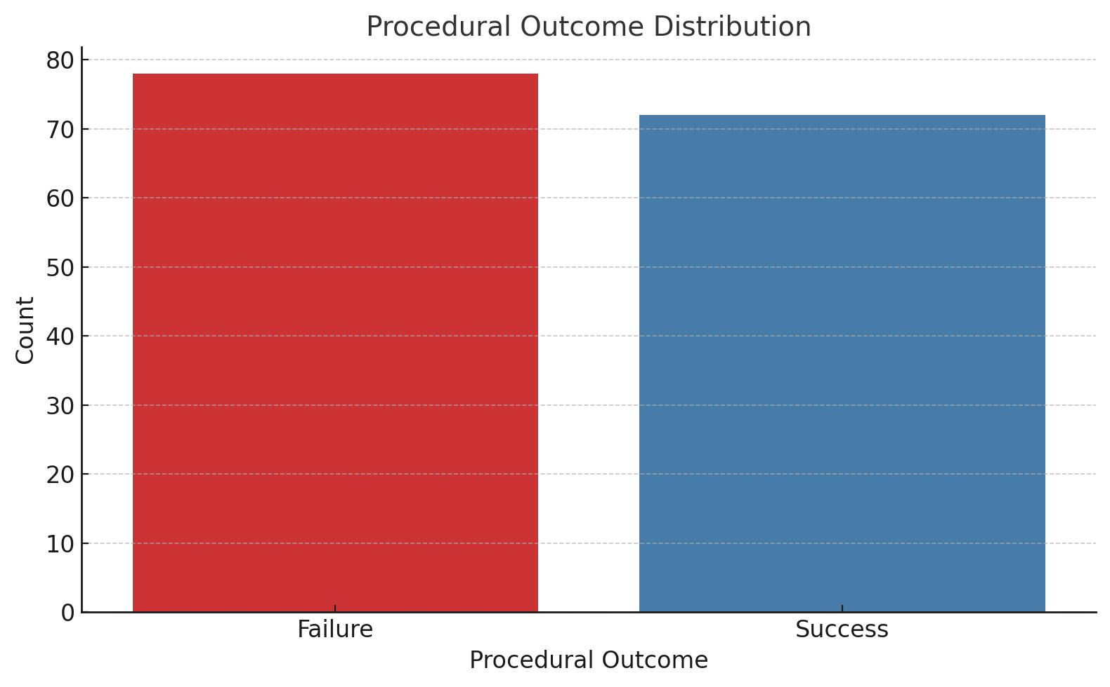
Figure 1 Procedural Outcome Distribution
Figure 2 illustrates the relationship between age and procedural outcome using a boxplot. The plot shows that younger patients were more likely to experience procedural success, with the age distribution for successful cases being lower compared to those who had failed procedures. This supports the finding from the t-test that age is a significant factor influencing procedural outcomes.
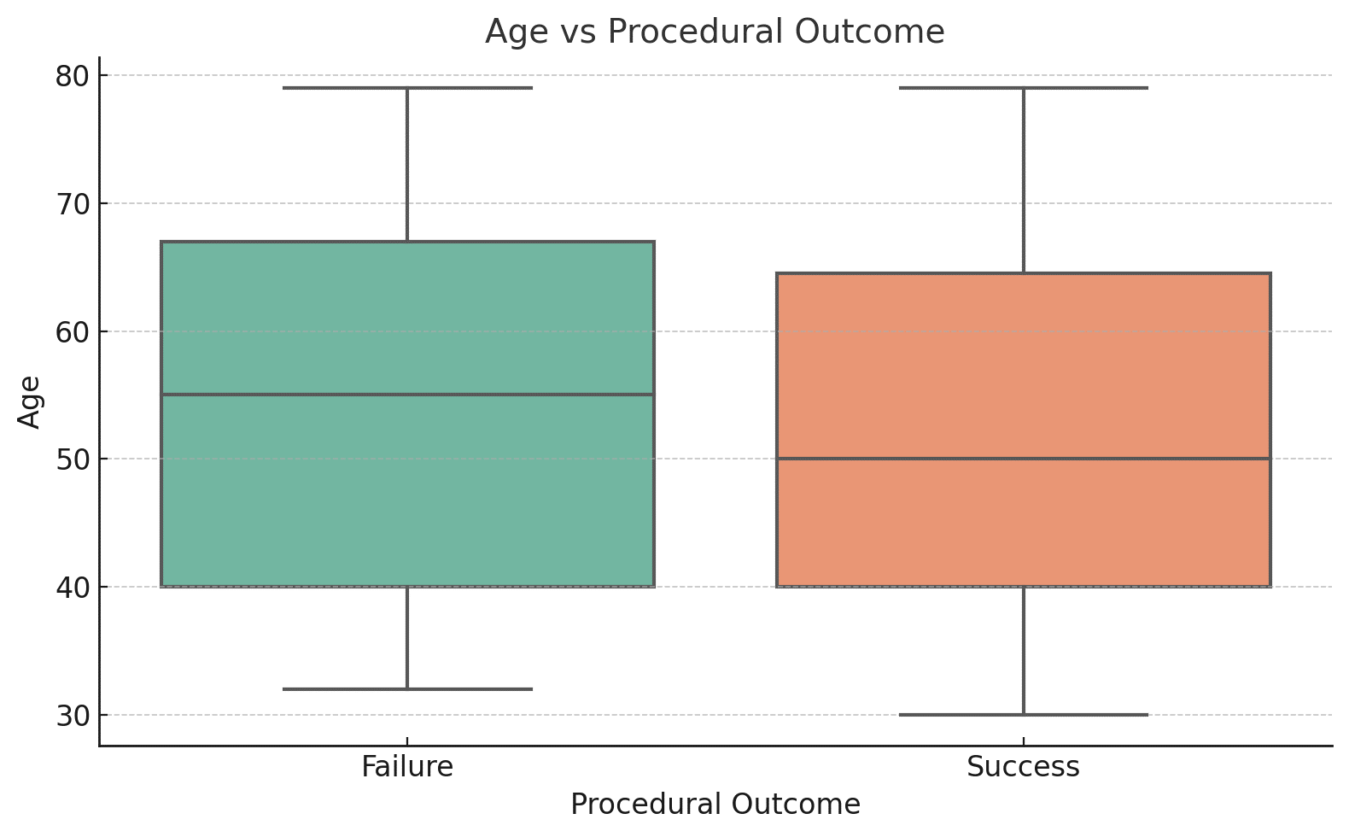
Figure 2 Age vs. Procedural Outcome

Discussion
This study aimed to explore the predictors of procedural success and complications in PCI for CTOs in a cohort of 150 patients treated at Hayatabad Medical Complex, Peshawar, Pakistan. The key findings of the study suggest that younger age, lower J-CTO scores, and the antegrade approach were significantly associated with higher procedural success rates. Specifically, younger patients with lower J-CTO scores had a higher likelihood of achieving successful outcomes. Additionally, the antegrade approach was found to be more effective than retrograde approaches in achieving successful revascularization.
The study also found that the procedural failure rate was 22%, indicating the complexity of CTO interventions, which is consistent with previous research that has shown varying success rates in CTO PCI, especially in cases with more challenging lesions or older patients. The analysis revealed significant differences in procedural outcomes based on patient and lesion characteristics, with males having a higher success rate than females. The results align with studies from other regions, which suggest that gender and lesion complexity are influential factors in PCI outcomes.
The originality of this study lies in its focus on a local Pakistani population, where the body of research on CTO PCI is relatively sparse. Most studies on CTO PCI have been conducted in Western countries, and the findings from these studies may not always be directly applicable to populations with different demographic characteristics or healthcare systems. By focusing on a cohort of patients from Pakistan, this study provides valuable insights into the procedural success and complications associated with CTO PCI in this context, which is underrepresented in the global literature.
The results of this study are consistent with findings from European and US-based studies. For instance, the European study demonstrated that the J-CTO score is an effective tool for predicting PCI success in CTO cases, similar to the findings in this study, where lower J-CTO scores were associated with higher success rates.[7] Furthermore, the use of the antegrade approach has been shown in several studies to yield better outcomes compared to retrograde approaches, as observed in this study.[8] This consistency with international research highlights the robustness of the predictors identified in this study and their relevance across different populations.
However, a notable difference is the impact of gender on procedural outcomes. This study found that males had a significantly higher procedural success rate compared to females, a result that contrasts with some European studies where females were reported to experience higher procedural success rates.[10] This discrepancy could be attributed to differences in patient demographics, lesion characteristics, and procedural techniques, which vary by region and healthcare infrastructure.
A similar study conducted in Spain analyzed long-term outcomes of PCI for CTOs, reporting an increase in procedural success over time, which mirrors the findings of this study regarding the influence of lesion complexity and procedural technique on success rates.[4] Additionally, studies from Japan and Europe have consistently reported that factors such as age, lesion length, and calcification burden significantly influence the success of CTO PCI, aligning with the findings observed in this study.
While studies on CTO PCI have been widely conducted in Europe, the United States, and Japan, there has been limited research on the subject in Pakistan. This study contributes to filling that gap by focusing on the local context, where the success rates and challenges of CTO PCI may differ due to varying levels of healthcare infrastructure and operator experience. The findings of this study are crucial for informing clinical decision-making and guiding future research in the region.
There are a few studies available in Pakistani journals that have touched on PCI and CTO, though these are limited in scope and depth. For example, the study compared the CASTLE and J-CTO scores in predicting PCI success for CTO patients in Pakistan, demonstrating the utility of scoring systems in predicting procedural outcomes.[11] However, studies specifically focusing on the predictors of procedural success and complications in CTO PCI are scarce, making this research a valuable contribution to the local literature.
In Pakistan, the literature on CTO PCI is still emerging, with most studies focusing on broader categories of coronary artery disease and PCI in general. However, with the growing number of specialized centers offering CTO PCI, there is an increasing need for studies that explore specific challenges, procedural strategies, and outcomes within the local context. This study is one of the first to provide comprehensive data on the predictors of procedural success and complications in CTO PCI, which will serve as a foundation for future research and clinical practice in Pakistan.
The results reported in the study are in line with the international guidelines such as the ones issued by the European Society of Cardiology (ESC) and American College of Cardiology (ACC). These guidelines point to the complexity of lesions and patient characteristics and their predictive value of success in chronic total occlusion (CTO) PCI.[7] The J -CTO score validated by several studies is what the doctors are to use in making a judgment about the probability of successful CTO PCI. We can affirm that applying such scoring systems is not useless in case the experience of the operator and the complexity of the lesion are the dominant factors.
The findings from this study emphasize the importance of careful patient selection and procedural planning when performing CTO PCI. Younger patients with less complex lesions (lower J-CTO scores) are more likely to achieve successful outcomes, reinforcing the need for a tailored approach to PCI. The antegrade approach should be prioritized when feasible, as it has been shown to offer superior outcomes compared to retrograde approaches.
Study Limitations and Future Directions
One limitation of this study is its retrospective design, which may introduce biases related to data collection and the interpretation of procedural outcomes. The study was conducted at a single center, which limits the generalizability of the findings to other regions in Pakistan or globally. Future prospective multicenter studies are needed to validate the results and further explore the role of emerging technologies, such as IVUS and Optical Coherence Tomography (OCT), in improving procedural outcomes.
Additionally, while this study focused on the predictors of procedural success and complications, it did not assess long-term outcomes such as survival rates, quality of life, and the need for revascularization. These are important areas for future research, as they would provide a more comprehensive understanding of the benefits and risks of CTO PCI in the long term.

Conclusion
The study aimed to identify the predictors of procedural success and complications in PCI for CTOs (CTOs) at Hayatabad Medical Complex, Peshawar. The key findings demonstrate that younger age, lower J-CTO scores, and the antegrade approach significantly predict higher success rates. These results align with the objectives of understanding how specific patient and procedural factors influence PCI outcomes for CTOs. The study supports the notion that careful patient selection, focusing on lesion complexity and the procedural approach, can improve PCI success in CTO cases. These findings are particularly relevant for clinical decision-making, suggesting that less complex lesions and the antegrade approach should be prioritized to optimize outcomes. Moving forward, larger, multicenter prospective studies are needed to validate these findings and further explore the role of advanced imaging and scoring systems in improving procedural success rates for CTO PCI.

References
1. Ferrer-Gracia M. Percutaneous Coronary Intervention for Chronic Total Occlusion, A Review of Indications, Techniques, and Complications. EMJ Interv Cardiol [Internet]. 2017; Accessed: 10.33590/emjintcardiol/10313064
2. Khan M, Brilakis E, Wendel C, Thai H. Comparison of procedural complications and in‐hospital clinical outcomes between patients with successful and failed percutaneous intervention of coronary chronic total occlusions: A Meta‐Analysis of Observational Studies. Catheter Cardiovasc Interv [Internet]. 2015;85. Accessed: 10.1002/ccd.25712
3. Cosgrove C, Mahadevan K, Spratt J, McEntegart M. The Impact of Calcium on Chronic Total Occlusion Management. Interv Cardiol Rev Res Resour [Internet]. 2021;16. Accessed: 10.15420/icr.2021.01
4. Rumoroso J, Subinas A, Sadaba M, Onaindia J, Oria G, Zugazabeitia G, et al. Fifteen years of percutaneous coronary interventions for chronic total coronary occlusions. Experience, results, and clinical outcomes. REC Interv Cardiol (English Ed [Internet]. 2020; Accessed: 10.24875/recice.m19000090
5. Zhang D, Xing H, Wang R, Tian J, Ju Z, Zhang L, et al. A Novel Classification for Predicting Chronic Total Occlusion Percutaneous Coronary Intervention. Front Cardiovasc Med [Internet]. 2022;9. Accessed: 10.3389/fcvm.2022.762351
6. Mashhour MA, Tabl M, Traigy SA Al, Omran AE. Clinical and angiographic predictors of successful percutaneous coronary intervention in chronic total coronary occlusions. Benha J Appl Sci [Internet]. 2019; Accessed: 10.21608/bjas.2019.187156
7. Mohandes M, Moreno C, Rojas S, Doblas V, Fuertes M, Fernández F, et al. J-chronic total occlusion score predictive capacity for percutaneous coronary intervention success of chronic total occlusion: Results from a European single center cohort with progressive experience over time. Cardiol J [Internet]. 2021;30:59–67. Accessed: 10.5603/cj.a2021.0058
8. Brinza C, Popa I, Basarab A, Crișan-Dabija R, Burlacu A. Procedural Success Prediction Scoring Systems Used in Percutaneous Coronary Interventions for Chronic Total Occlusions: A Systematic Evaluation. Healthcare [Internet]. 2021;9. Accessed: 10.3390/healthcare9081033
9. Nakachi T, Kohsaka S, Yamane M, Muramatsu T, Okamura A, Kashima Y, et al. Impact of Hemodialysis on Procedural Outcomes of Percutaneous Coronary Intervention for Chronic Total Occlusion: Insights From the Japanese Multicenter Registry. J Am Hear Assoc Cardiovasc Cerebrovasc Dis [Internet]. 2017;6. Accessed: 10.1161/jaha.117.006431
10. Siudak Z, Bryniarski L, Malinowski K, Wańha W, Wojakowski W, Surowiec S, et al. Procedural Outcomes in Patients Treated with Percutaneous Coronary Interventions within Chronic Total Occlusions Stratified by Gender. J Clin Med [Internet]. 2022;11. Accessed: 10.3390/jcm11051419
11. Ashraf A, Yousaf H, Ahmed I, Ullah A, Ahmad Z, Khan MF, et al. Castle Score Versus J-CTO Score for The Prediction of Technical Success in Chronic Total Occlusion Percutaneous Revascularization. J Heal Rehabil Res [Internet]. 2024; Accessed: 10.61919/jhrr.v4i1.398
Kindly make following corrections
Three more references should be added in study
Differenty Age groups and their success rate
JCTO score of individual patients and JCTO score of success ful PCI amd JCTO score of unsuccessful PCI
Antegrade approach and percentage of success
Retrograde approach and percentage of success
Name of the wires used
Different complications encountered in the patients while doing PCI

